**You will need to download two applications if you are using a smart phone**

1. **Patient Access**
2. **Google Authenticator**

**Create your Patient Access account**

* Continue to create your account

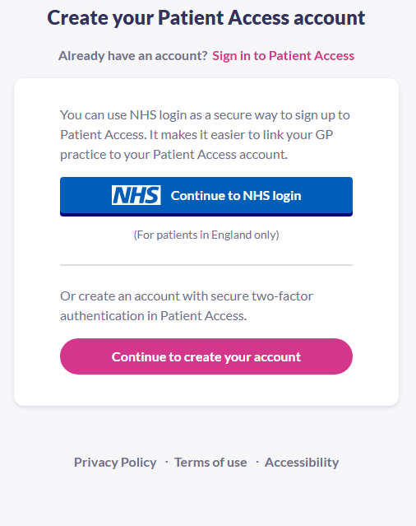

• Enter your personal details.

**Keeping your account secure – Authenticator – 6 digit code**

* You will be prompted to install an authenticator app (Google Authenticator seems to be the easiest to use)

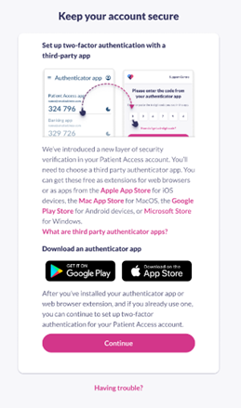

* Click continue

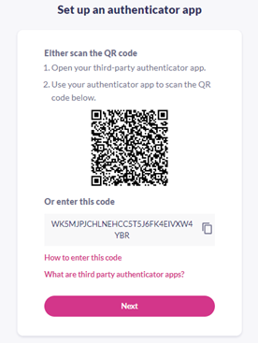

* Copy the code
* Open authenticator app that you have downloaded
* Add a new code and name it “Patient Access”
* Paste the code that you copied as above
* This will then produce a 6 digit code which will change ever minute
* Open the Patient Access App and enter the 6 digit code given in the authenticator app
* Click “Done”
* Your account has been created.

**Linking to your GP Practice**

* Click the “patient services” tab at the bottom of the app
* You will then be asked to link to your GP practice
* Below the question 'Have you received a registration letter from your practice?', select Yes.
* Enter the Linkage key (which is recorded on the registration letter either sent to you via email or in paper form).
* Enter the ODS Code
* Enter the Account ID (which is recorded on the registration letter).
* Select Confirm.
* Check your personal details and enter either your house number, flat number, or street number, then select Continue.
* Note: The personal details must match the details held by your practice.
* On the confirmation screen, select Done.
* Your account has been linked to your practice.
* **You will now be able to order repeat medications through the “patient services” tab at the bottom of the screen**