You will need to download two applications if you are using a smart phone
- Patient Access
- Google Authenticator

Create your Patient Access account
- Continue to create your account
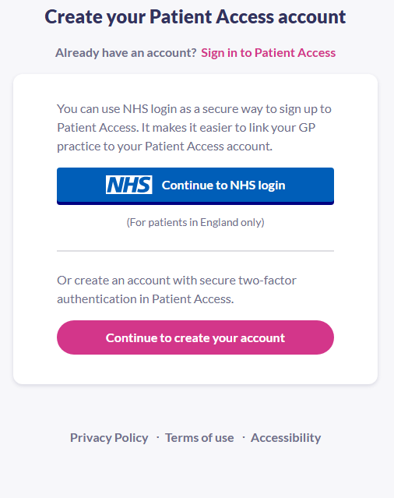
• Enter your personal details.
Keeping your account secure – Authenticator – 6 digit code
- You will be prompted to install an authenticator app (Google Authenticator seems to be the easiest to use)
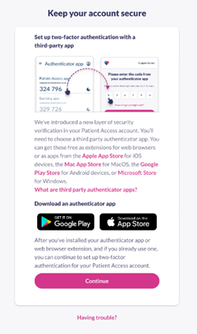
- Click continue

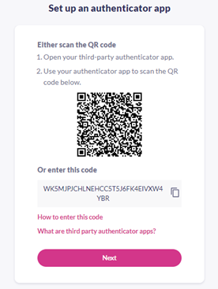
- Copy the code

- Open authenticator app that you have downloaded

- Add a new code and name it “Patient Access”

- Paste the code that you copied as above

- This will then produce a 6 digit code which will change ever minute

- Open the Patient Access App and enter the 6 digit code given in the authenticator app

- Click “Done”

- Your account has been created.
Linking to your GP Practice
- Click the “patient services” tab at the bottom of the app
- You will then be asked to link to your GP practice
- Below the question 'Have you received a registration letter from your practice?', select Yes.
- Enter the Linkage key (which is recorded on the registration letter either sent to you via email or in paper form).

- Enter the ODS Code

- Enter the Account ID (which is recorded on the registration letter).

- Select Confirm.

- Check your personal details and enter either your house number, flat number, or street number, then select Continue.

- Note: The personal details must match the details held by your practice.

- On the confirmation screen, select Done.

- Your account has been linked to your practice.

- You will now be able to order repeat medications through the “patient services” tab at the bottom of the screen

